Task 1: Network Devices Feature & Port Comparison Table

Network Device | Primary Layer | Core Function in a Home/SOHO Network | Typical Ports & Interfaces
Router | Layer 3 (Network) | Routes packets between different subnets (e.g., LAN to ISP WAN), runs DHCP, and performs NAT. | • 1× RJ-45 WAN (Internet) Port  • 4× RJ-45 LAN Ports  • 1× DC Barrel Power Jack  • Optional USB (Storage/Modem)
Switch | Layer 2 (Data Link) | Connects multiple wired Ethernet devices on the local segment and forwards frames via MAC addresses. | • 4 to 24+ RJ-45 Gigabit Ethernet Ports  • Optional SFP/SFP+ optical uplink ports  • AC Power / DC Barrel Input
Hub | Layer 1 (Physical) | Legacy multiport repeater; broadcasts incoming electrical signals across all connected ports without filtering. | • 4 to 8× RJ-45 Ethernet Ports  • DC Power Input
Firewall | Layer 3 / 4 (to Layer 7 NGFW) | Filters ingress and egress traffic using stateful inspection rules to block malicious incoming scans. | • Dedicated RJ-45 WAN / Untrusted Port  • Dedicated RJ-45 LAN / Trusted Ports  • RJ-45 / Micro-USB Console Port
Access Point (AP) | Layer 2 / Layer 1 | Converts wired Ethernet network data into radio frequency waves (Wi-Fi) to provide wireless access. | • 1–2× RJ-45 Ethernet Uplink Ports (PoE-enabled)  • External/Internal RF Antennas  • DC Power Jack (if not PoE)

Task 2: Identify Network Devices and Ports
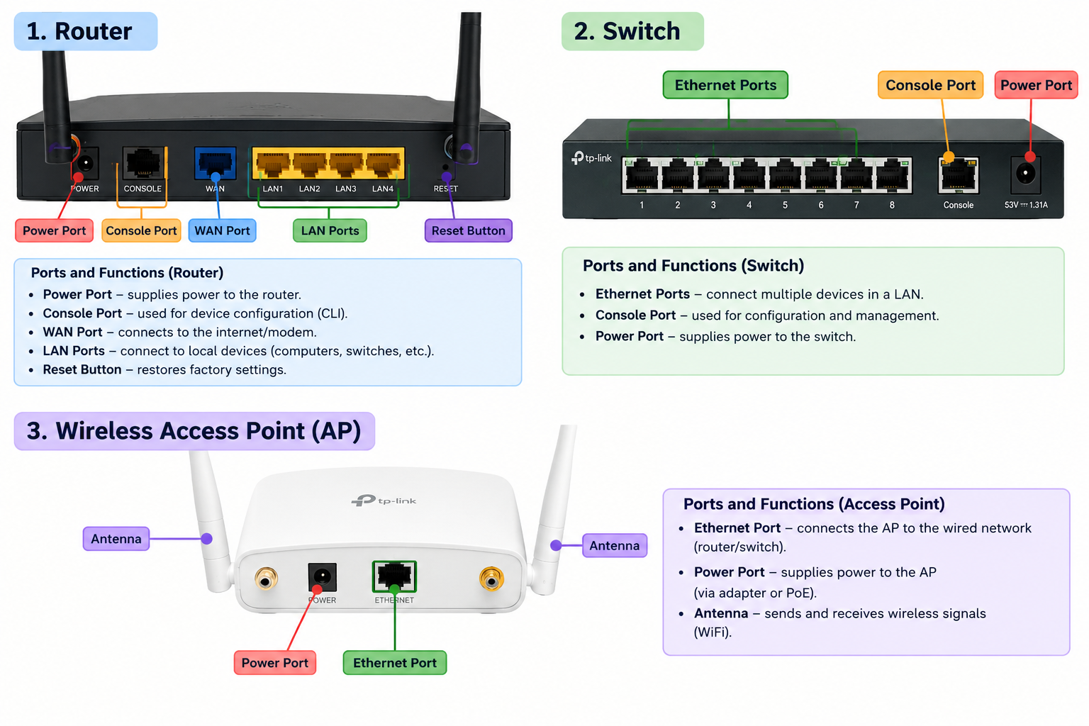

Task 3: Device Roles in Everyday App Usage (Paytm)

When scan a QR code and make a payment on Paytm:
- Access Point: Captures the payment request broadcast over Wi-Fi from smartphone antenna, translates the radio signals into standard 802.3 Ethernet frames, and delivers them onto the local wired infrastructure.
- Firewall: Performs stateful packet inspection on the transaction payload, ensuring no unauthorized connection attempts hijack the payment session while verifying that outbound traffic complies with secure HTTPS (Port 443) rules.
- Router: Rewrites your phone's internal IP address to a public IP using Network Address Translation (NAT) and calculates the optimal next-hop route across the ISP gateway to reach Paytm's banking API servers.

Task 4: Troubleshooting Slow College Wi-Fi

- Identified Root Cause: Access Point Capacity Saturation & Radio Channel Congestion
Enterprise lecture halls and common areas often have hundreds of students attempting to connect to older 802.11ac (Wi-Fi 5) access points. These older APs have limited spatial streams, narrow channels, and lower client-association thresholds, causing severe channel contention, frame collisions, buffer bloating, and dropped associations during peak class hours.
- Recommended Upgrade & Impact:
Upgrade the edge Access Points to Wi-Fi 6 / 6E (802.11ax) Multi-Gigabit APs with OFDMA and MU-MIMO.
  - Why it solves the issue: Wi-Fi 6 divides frequency channels into sub-carriers using OFDMA (Orthogonal Frequency-Division Multiple Access), allowing a single access point to communicate with dozens of active devices simultaneously rather than queuing them in a single line. This eliminates random disconnections, reduces latency, and handles high-density student environments effectively.

